**JECRC – 45 Days In-campus Training (4 Semester)**

**Subject – Full Stack Web Development**

# Day 8: 23th May, 2024

# Topic – position

**Assignment 6:-**

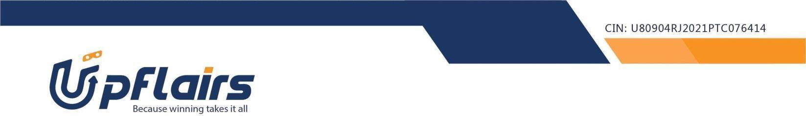 1. make the following webpage -



Note-upload your code to your github repo and share the url

Assignment submission form link - https://forms.gle/SLYTMLmQnekjqa3Y8